

**Team Name: Singleton**

**Team Members**

The project was carried out by :

* Nivethitha R – [nivethithar21@karunya.edu.in](mailto:nivethithar21@karunya.edu.in)

**Mentor**

I would like to express my gratitude to my mentor for providing constant support and guidance throughout the internship.

* Dr.Esther Daniel(Academic Mentor) [-estherdaniel@karunya.edu](mailto:-estherdaniel@karunya.edu)
* Mr. Abhishek Nandy(Industrial Mentor) - [abhisheknandy@theprograms.in](mailto:abhisheknandy@theprograms.in)

**ABSTRACT**

ATPs are designed to collect payment from consumers by cash, cheque, or DD. It will be unmanned and can be operated by the customers 24/7. It accepts cash/cheque/DD/pay order, issues an acknowledgment on every payment made and is a touchscreen and multimedia-based system. When the customer places the voucher/bill in the designated slot under the barcode scanner, the ATP will automatically get started. Suitable prompts are provided for guidance.

The ATP captures data from the voucher/bill and will display parameters on the monitor. A customer needs to choose the mode of payment. Once the amount is confirmed by the customer, the ATP will give directions on cash/cheque insertion. Parameters such as cheque number etc are read from the MICR fields and an acknowledgment is issued to the customer with the bill.

**Introduction**:

The ATP machine is an automatic machine which is used for the payment of electricity bill. ATPs are designed to collect payment from consumers by cash, cheque, or DD. It will be unmanned and can be operated by the customers 24/7. It accepts cash/cheque/DD/pay order, issues an acknowledgment on every payment made and is a touchscreen and multimedia-based system. When the customer places the voucher/bill in the designated slot under the barcode scanner, the ATP will automatically get started. Suitable prompts are provided for guidance. The ATP captures data from the voucher/bill and will display parameters on the monitor. A customer needs to choose the mode of payment. Once the amount is confirmed by the customer, the ATP will give directions on cash/cheque insertion. Parameters such as cheque number etc are read from the MICR fields and an acknowledgment is issued to the customer with the bill.

The ATP Machine has a touch screen, through which the consumers can enter their Service Number and pay the amount and get a receipt/statement of the amount paid. The machine has the provision to take currency notes. A separate slot will accept cheques in the same manner.

Machines of this new category are generally called Anytime payment kiosks. Apparently similar to the development of traditional mobile phones into smartphones, ATP machines have also progressively, though at a much slower pace, evolved into smart machines. Newer technologies at a lower cost of adoption, such as the large digital touch display, internet connectivity, cameras and various types of sensors, more cost-effective embedded computing power, digital signage, various advanced payment systems, and a wide range of identification technology (NFC, RFID, etc) have contributed to this development.. Integrated sensors and cameras also represent a source of such data as customer demographics and other locality-specific information. It also enables better customer engagement.

**APPROACH TO SOLVE THE PROBLEM**

**Define the System Requirements:**

* Determine the input and output requirements of the controller.
* Identify the necessary control signals and data paths.
* Specify any specific functionalities or constraints.

**Design the Finite State Machine (FSM):**

* Identify the different states the controller can be in.
* Define the state transition conditions and state outputs.
* Implement the FSM using Verilog constructs like always block and case statement.

**Implement the Input Handling:**

* Identify the input sources
* Design input registers to capture and store the input data.
* Implement the necessary logic to validate and process the inputs.

**Implement the Output Handling:**

* Identify the output devices
* Design output registers to store the data to be displayed or printed.
* Implement the necessary logic to control the output devices.

**Implement the Billing Logic:**

* Determine the billing algorithm and calculations.
* Design registers to store relevant billing information.
* Implement the necessary logic to calculate the bill amount.

**Implement the Payment Processing:**

* Design registers to store payment information.
* Implement the logic to verify payment methods.
* Update the billing information based on the payment received.

**Test and Debug:**

* Create testbench modules to simulate the controller's functionality.
* Generate test cases to verify different scenarios.
* Simulate and debug the design to ensure correct behavior.

**Synthesize and Implement:**

* Use a synthesis tool (such as Xilinx Vivado or Intel Quartus) to convert the Verilog code into a gate-level netlist.
* Implement the design on the target FPGA device or ASIC.

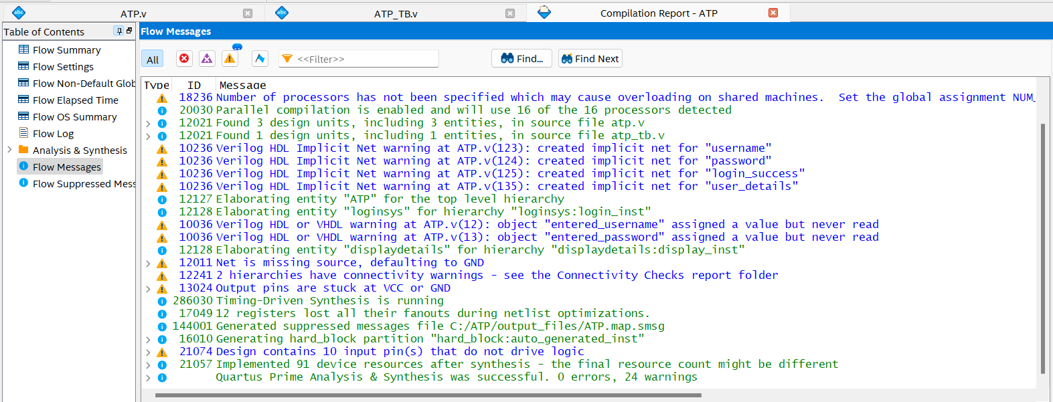

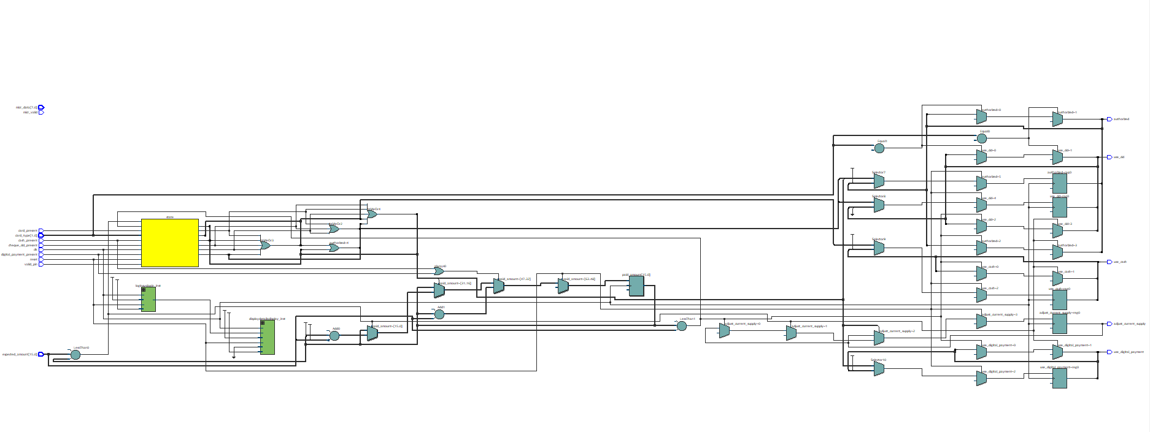

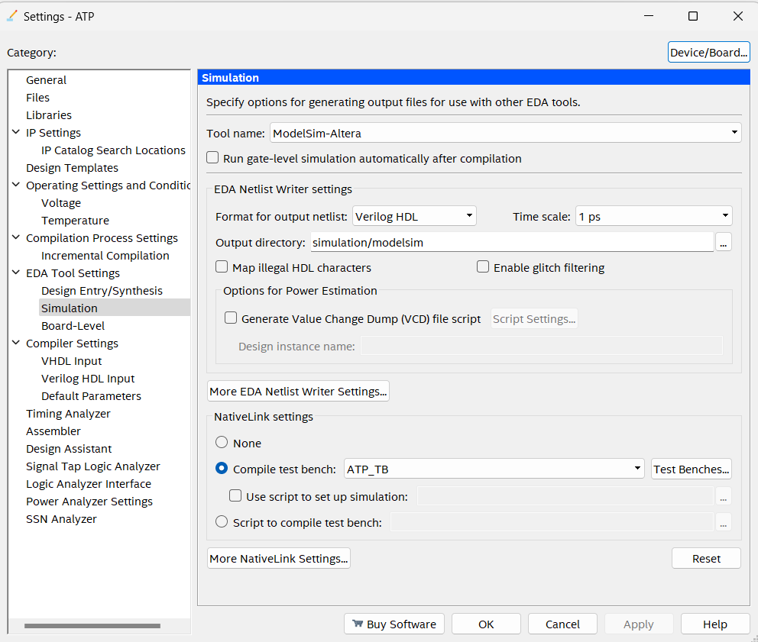

**DESIGN METHODOLOGY**

A) PROBLEM FORMULATION

The problem is defined as the design of an ATP machine that accepts cash, cheque/DD/Pay orders. The machine should possess additional features of returning change when more money is paid or reduced in subsequent payment returning and money when the request is canceled. The machine asks the customer to select the payment method. Therefore, the payment is one of the inputs. There is also a cancel option which is another input. The machine checks the paid amount with the total amount to be paid and prints the receipt if both are equal. If the customer inserts more money than the total amount, the machine gives the receipt along with the change or adds it to a subsequent cycle. Receipt and change are therefore outputs of the machine. Money is returned when the request is canceled. Therefore, return money is another output. Two registers are needed, one to keep track of the amount of the present transaction and the other to keep track of the total amount in the machine. The registers are taken to be ten-bit width each. When a higher amount is inserted, change can be given only if the total amount is higher than the present transaction. In this way, the machine checks whether the change is available or not.

In order to meet the above specifications, a finite state machine approach is adopted. The ASM chart and state diagram are drawn, and the corresponding Verilog code is formulated using behavioral modeling.

The subsequent sections deal with elaborate descriptions of the flowchart and state diagram of the ATP machine

B) BLOCK DIAGRAM AND FLOWCHART OF ATP MACHINE:

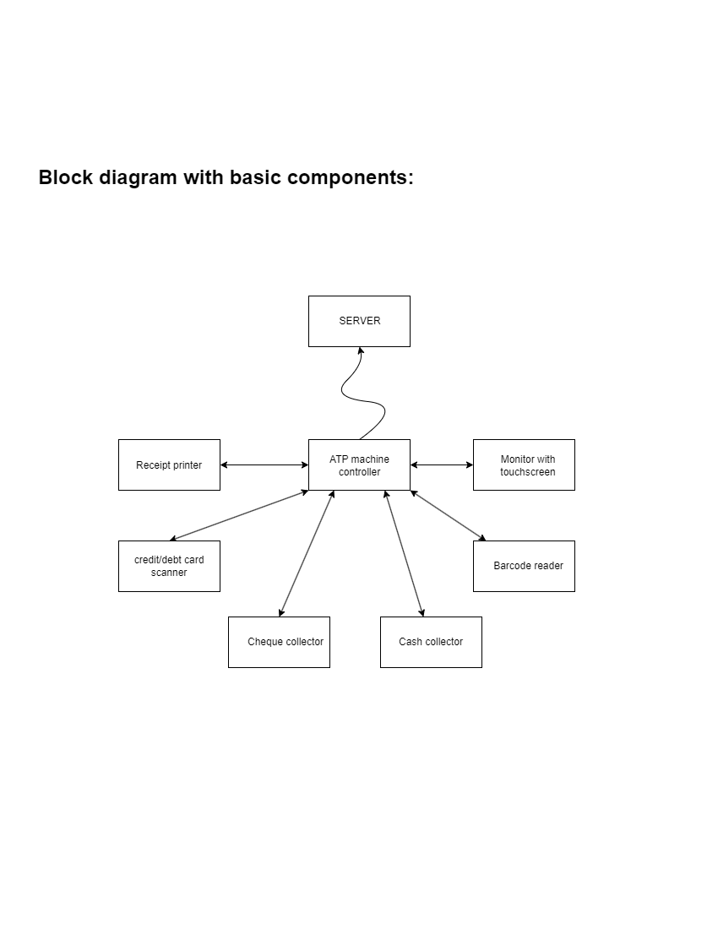

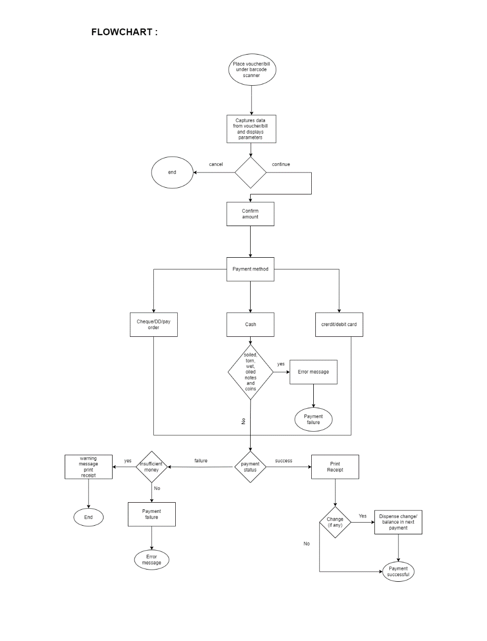

C) STATE DIAGRAM OF ATP MACHINE:

The flow of signals that lead to various states is shown in subsequent figure.

STATES:

1. IDLE: The initial state of the ATP.
2. STARTED: The ATP has been started, and an acknowledgment is issued with the voucher data.
3. CONFIRM_AMOUNT: The customer confirms the amount to be paid.
4. INSERT_CASH_CHEQUE: The customer inserts cash/cheque.
5. PROCESSING: The ATP processes the cash/cheque.
6. COMPLETED: The transaction is completed, and an acknowledgment is issued with the total amount and electricity charge.

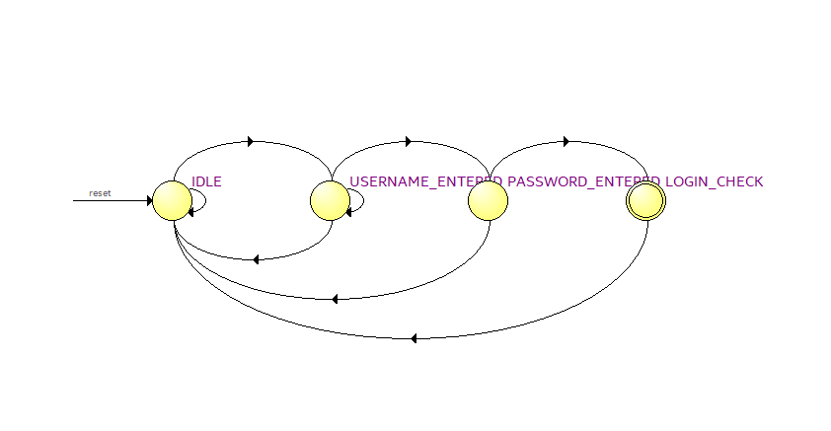

**The state diagram through RTL viewer.**

**RESULTS AND DISCUSSION**

The Verilog code has been formulated for the vending machine using behavioral modeling. The test bench has been written. The simulation has been performed. The simulation waveform is obtained as shown in the subsequent figure.

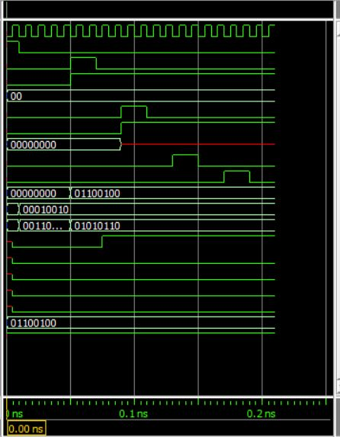

Compilation Report:

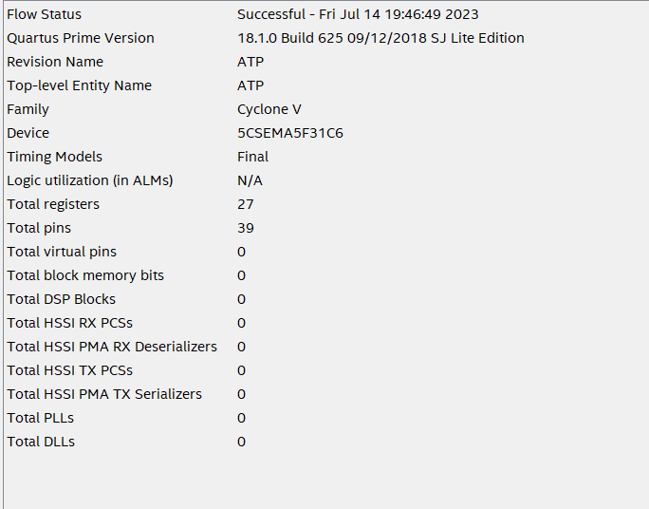

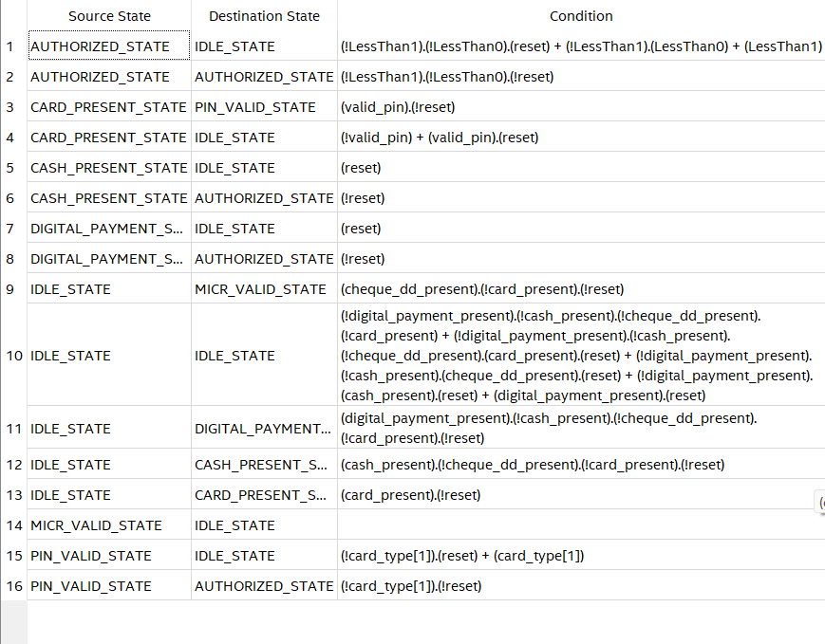

**CONCLUSION**

The ATP machine was successful, with the additional features of printing receipts along with returning change when a higher amount is paid and returning total money when the request is canceled. The ATP machine is successful in meeting the specifications laid out prior to the design.

**References:**

[**https://www.apspdcl.in/atp-machine.jsp**](https://www.apspdcl.in/atp-machine.jsp)

[**https://www.intel.com/content/www/us/en/programmable/customertraining/webex/Verilog/presentation_html5.html**](https://www.intel.com/content/www/us/en/programmable/customertraining/webex/Verilog/presentation_html5.html)

**BOOK reference:**

**Verilog HDL: A Guide to Digital Design and Synthesis**